**Final Case Study 1**

1. S3 bucket:

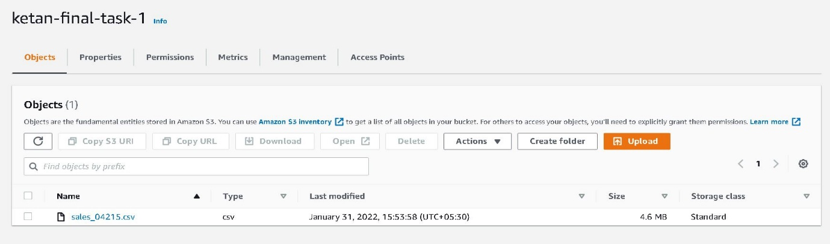

2. S3 bucket and lambda function configuration in event notification:

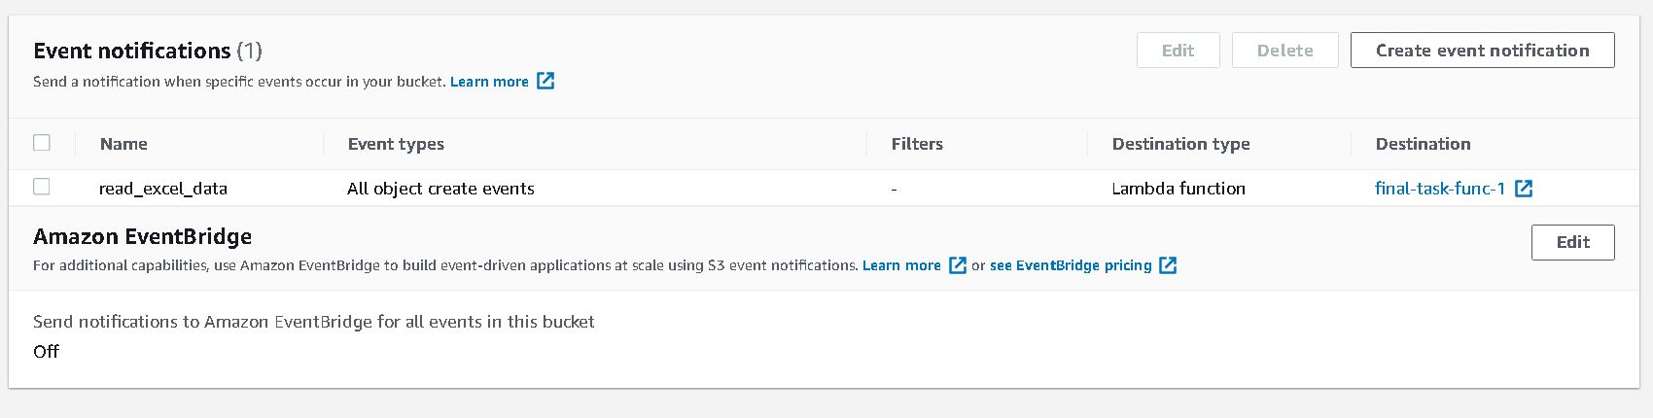

3. Lambda function 1 permissions:

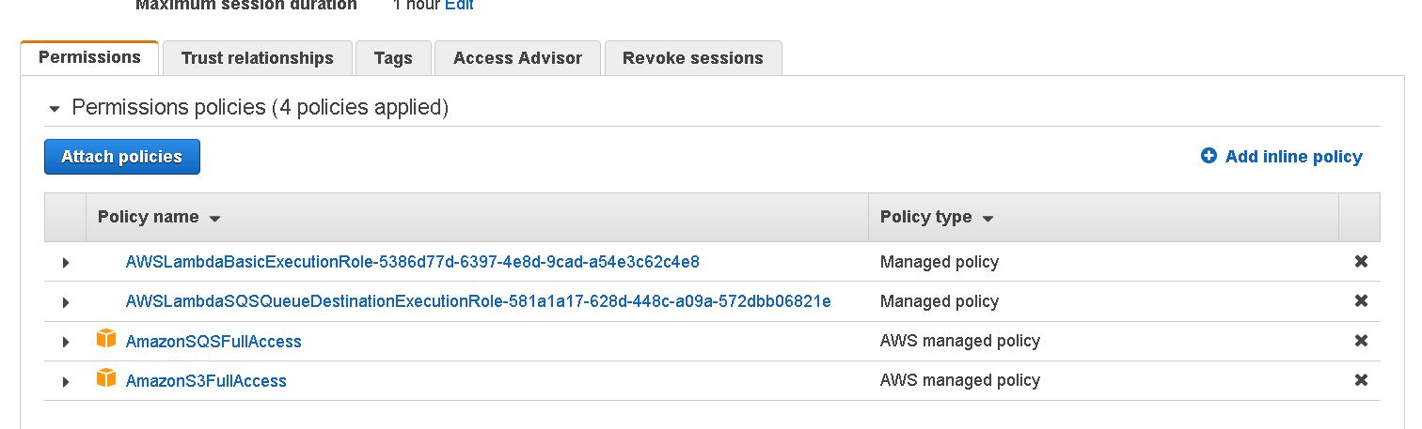

4. Lambda function 1 services:

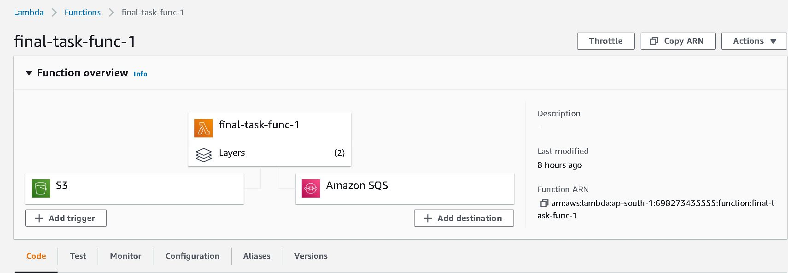

5. Lambda function 2 permissions:

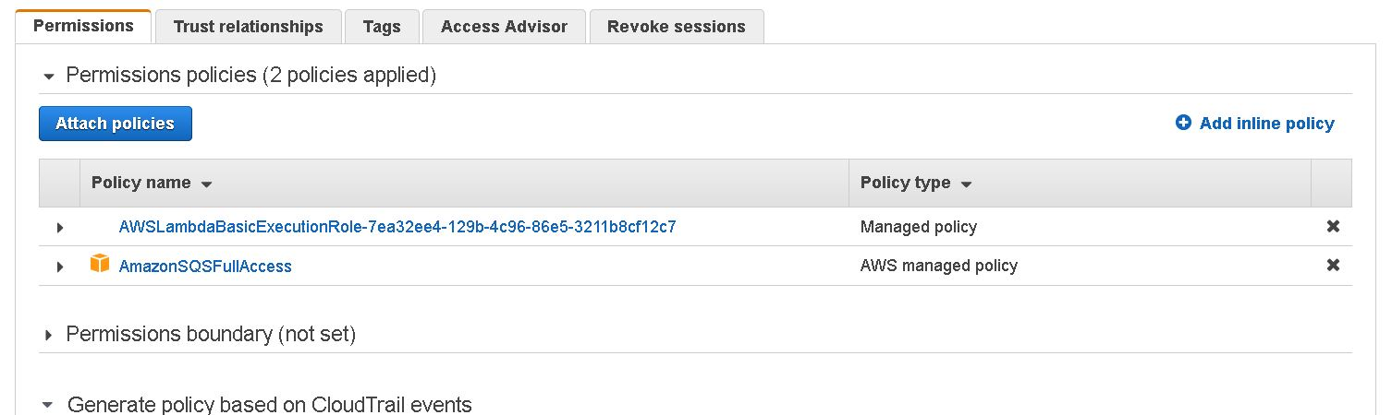

6. Lambda function 2 services:

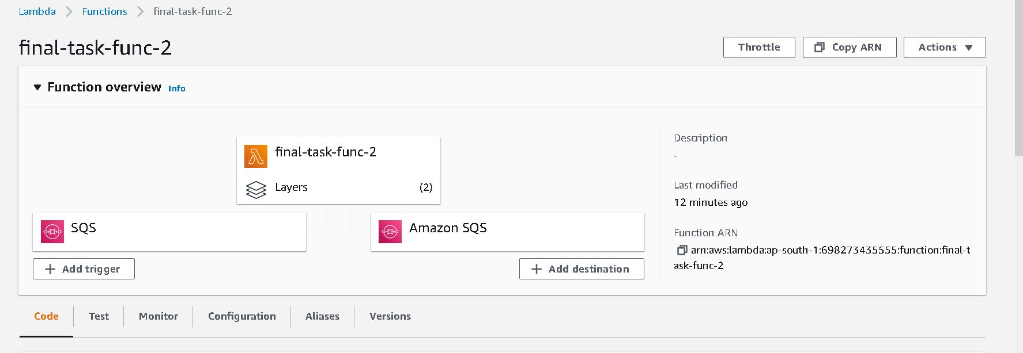

7. Lambda function 3 permissions:

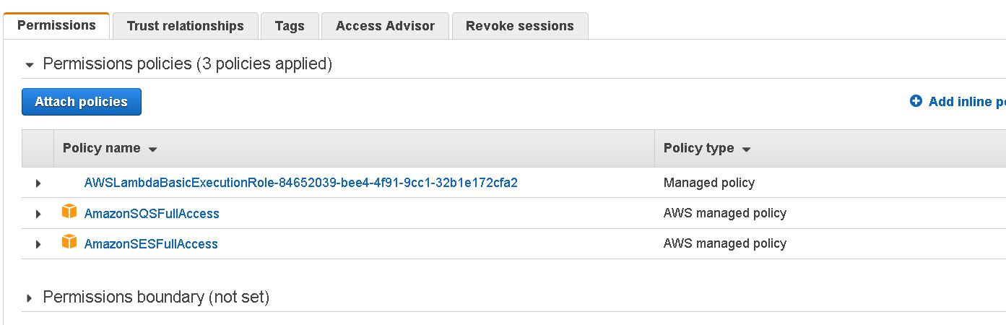

8. Lambda function 3 services:

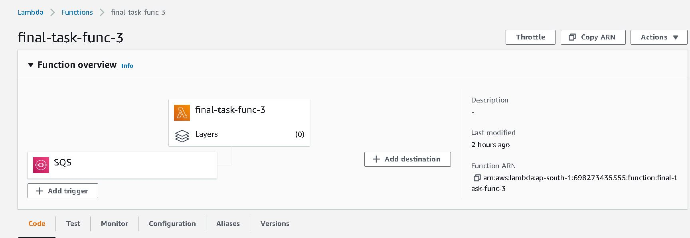

9. Lambda function 1 logs using Cloudwatch:

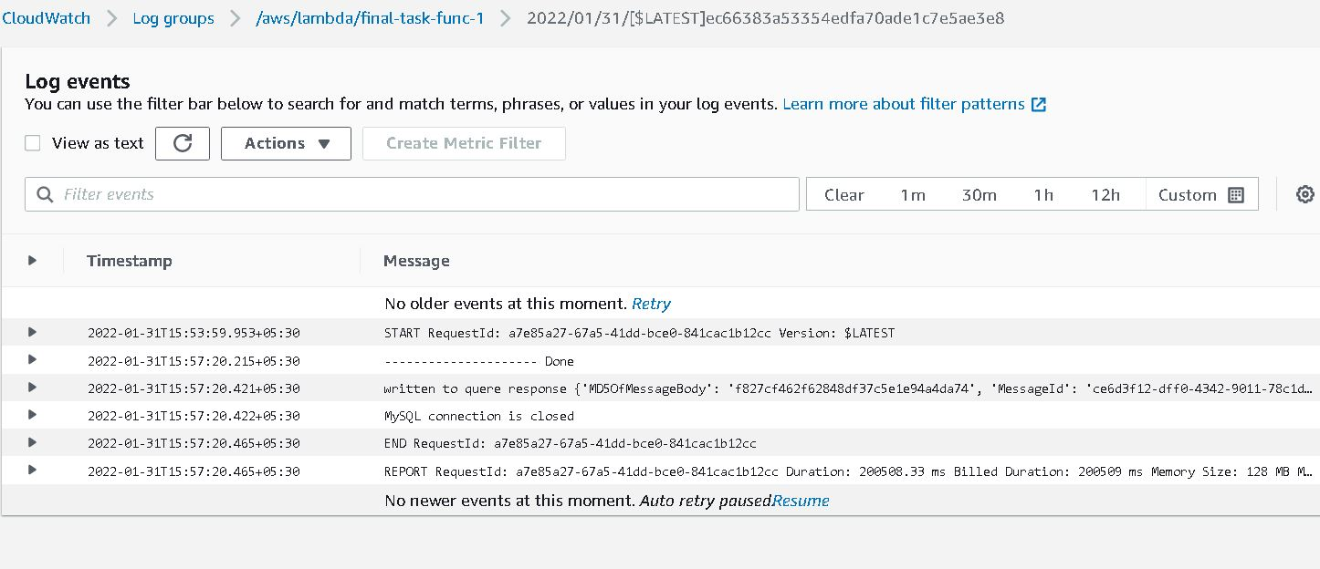

10. Lambda function 2 logs using Cloudwatch:

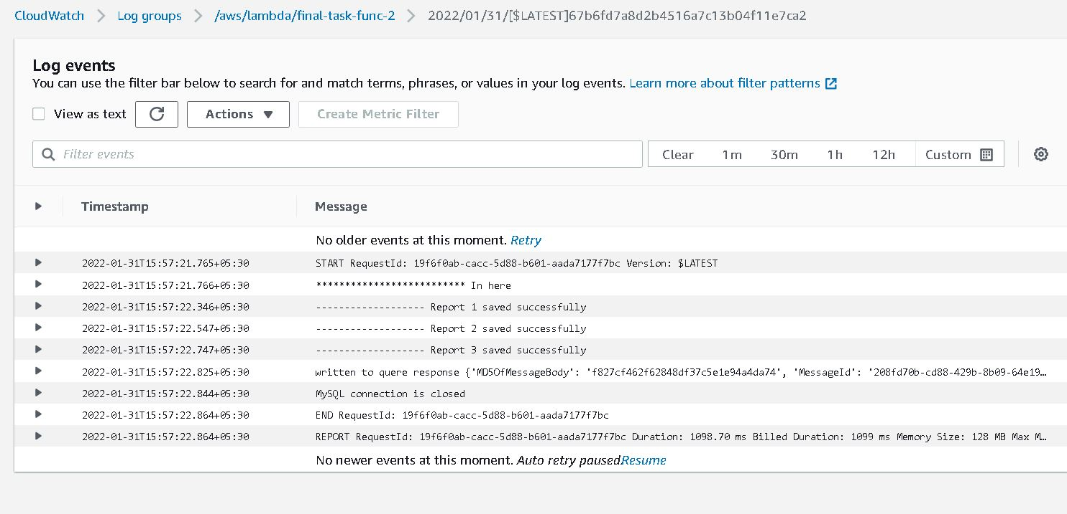

11. Lambda function 3 logs using Cloudwatch:

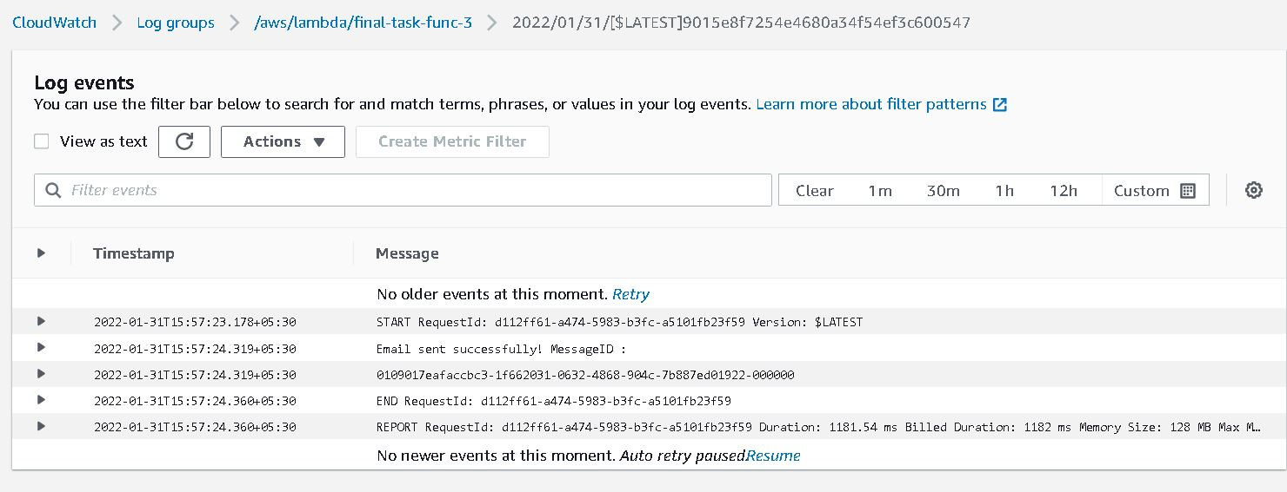

12. Dependencies added through zip folder:

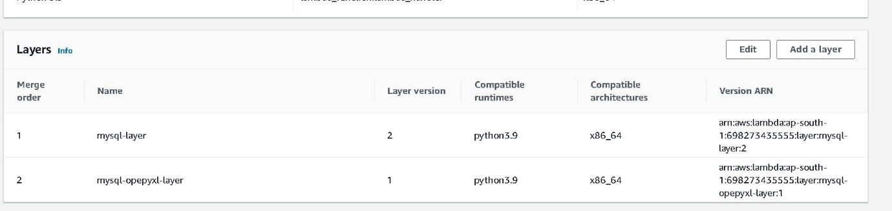

13. RDS Connection:

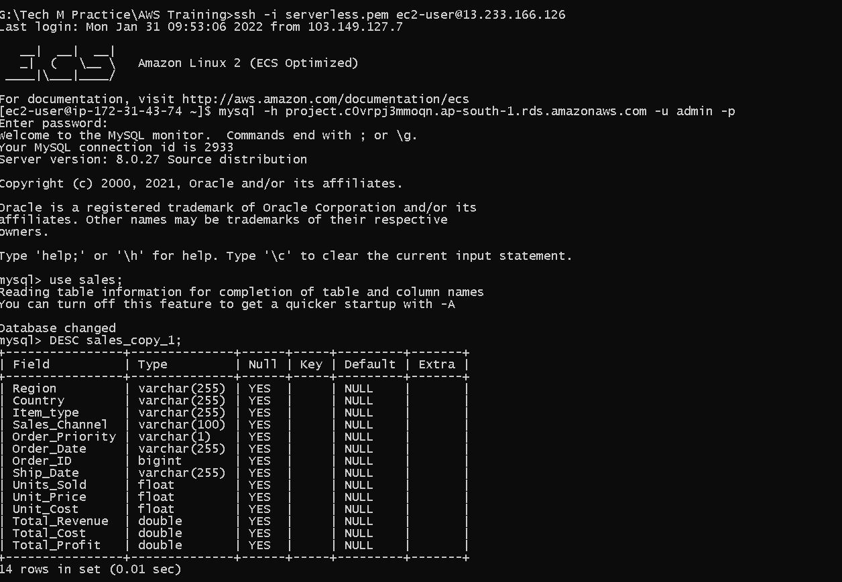

14. RDS Database Service Details:

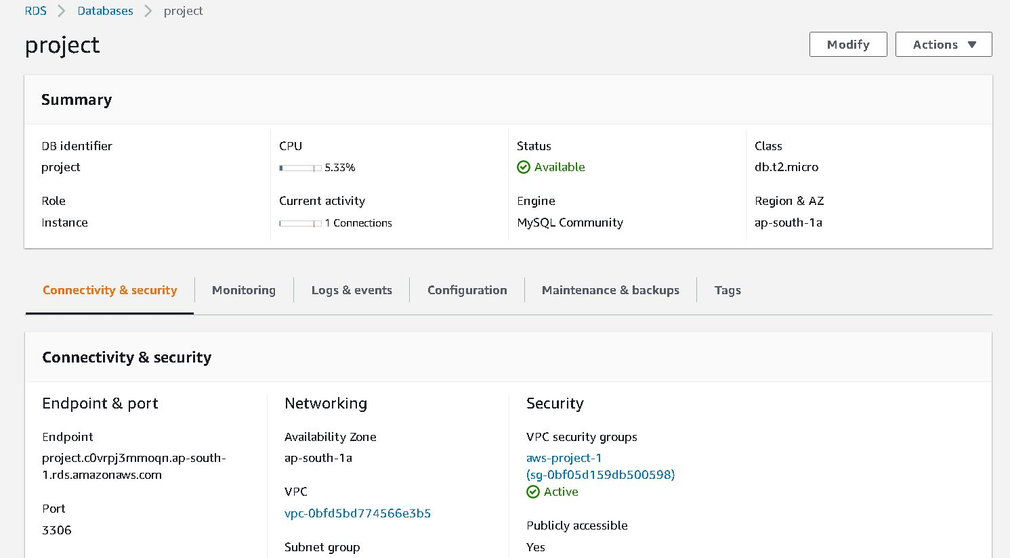

15. SQL Table Structure:

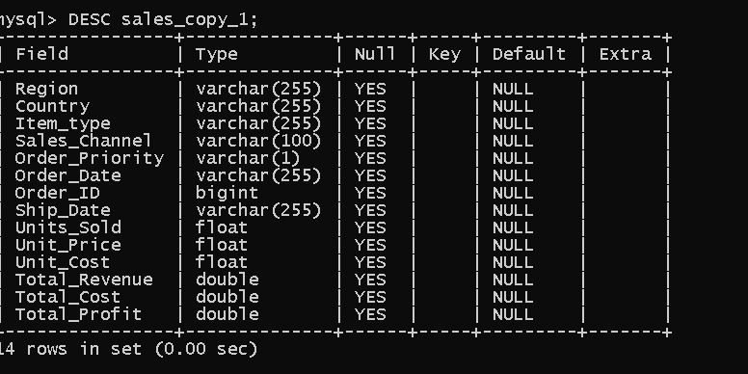

16. SQS – Lambda Configuration:

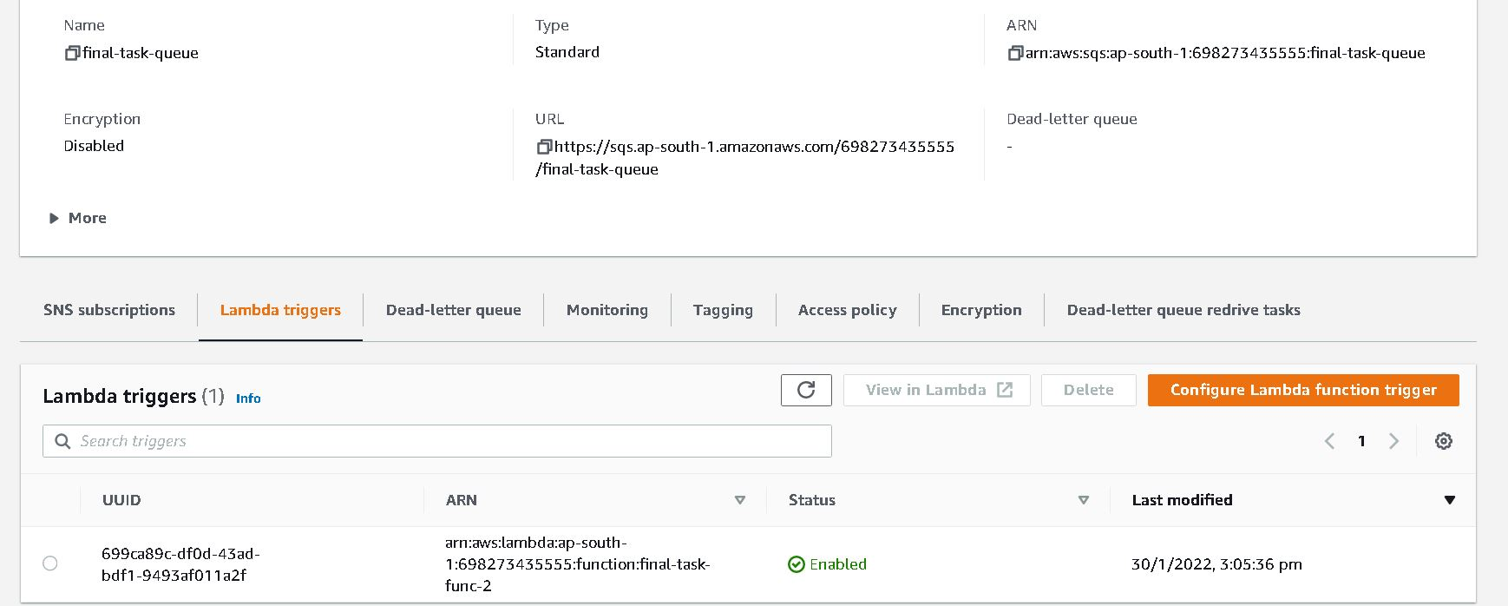

17. DB Data Inserted:

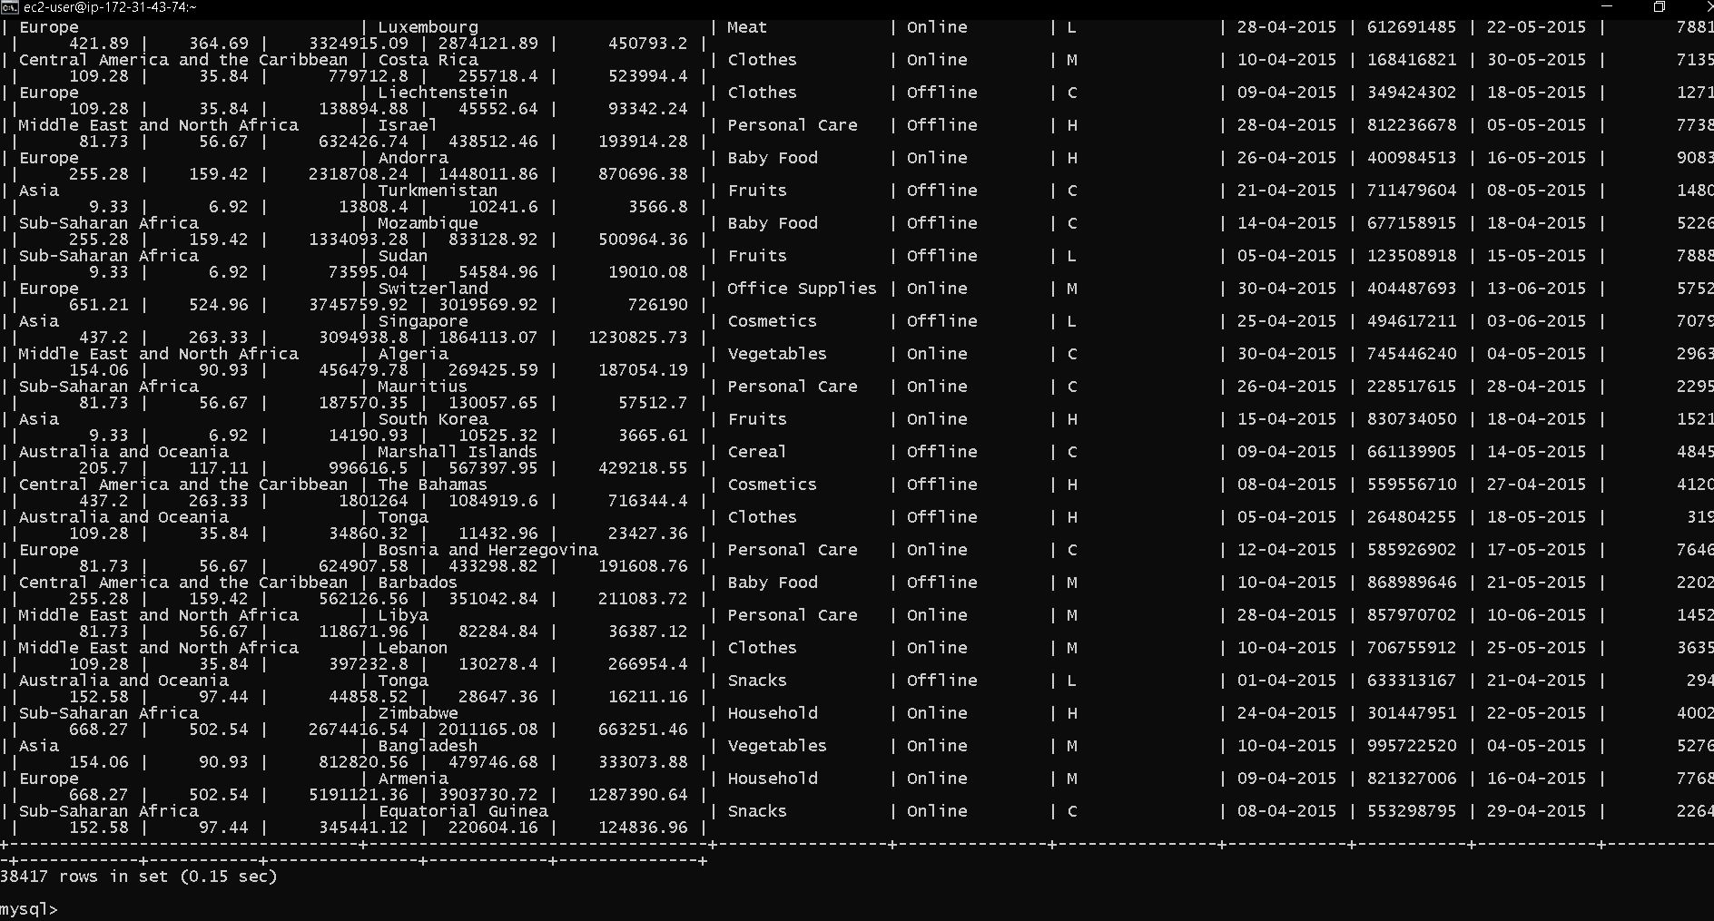

18. DB Data for Report 1:

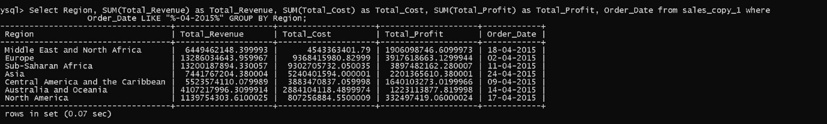

19. DB Data for Report 2:



20. DB Data for Report 3:

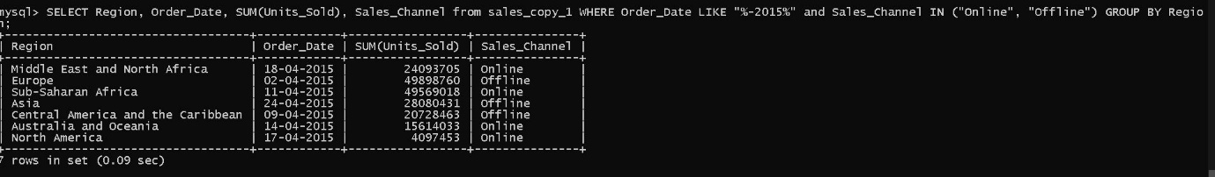

21. SES Email Account:

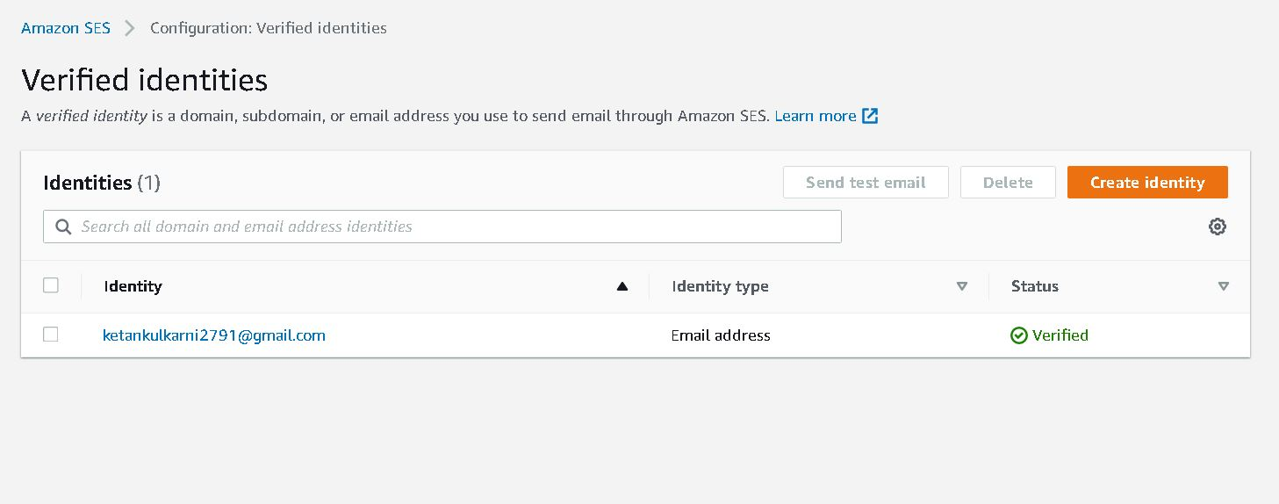

22. Email Received:

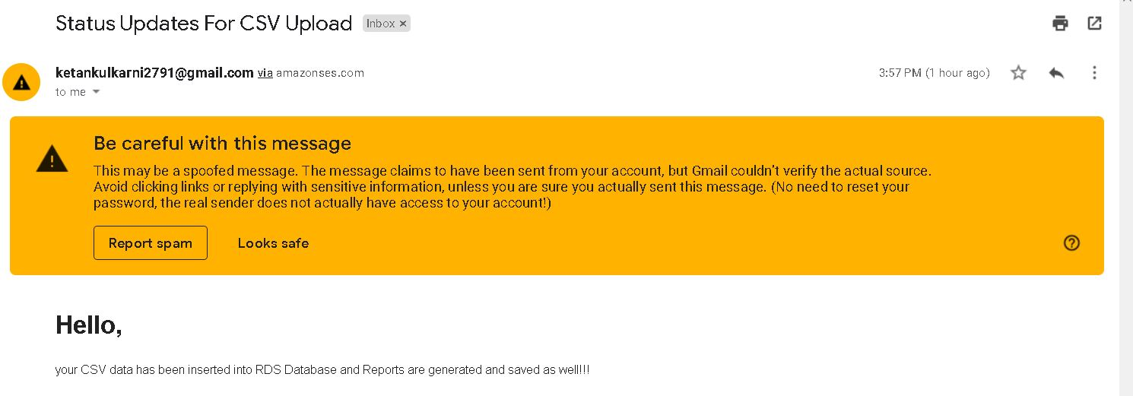

23. Time Out Edited for first lambda function:

